**Supplementary Material for Schilling et al,**

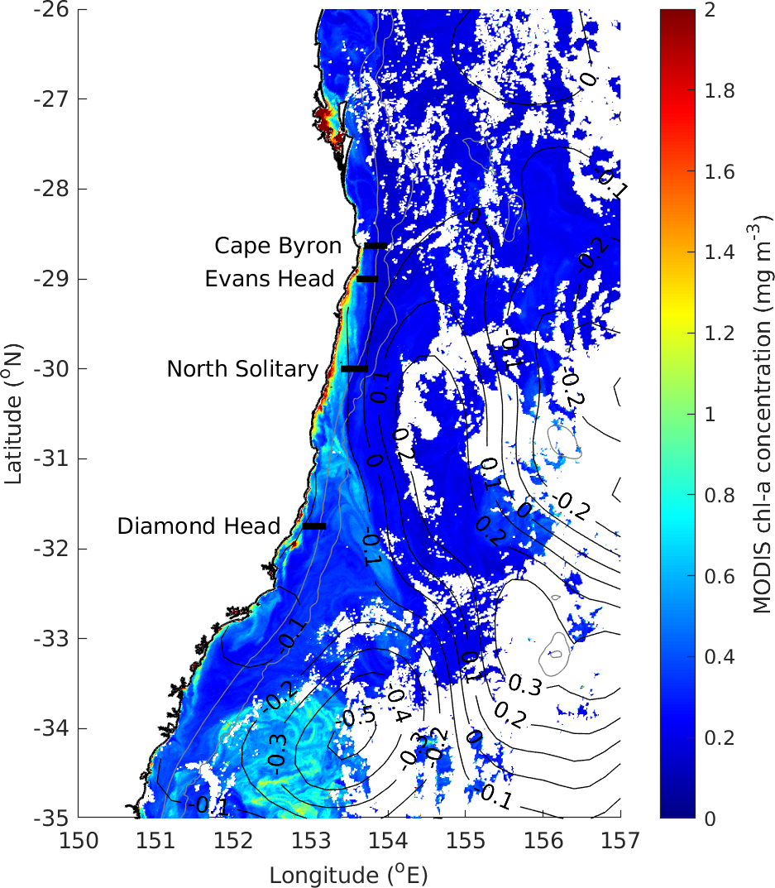

**Figure S1** MODIS Chlorophyll *a* (mg m-3) in the region during our study showing low amounts of Chlorophyll at all the transect sites (black lines) during our study. Black contour lines connect areas of equal sea surface height anomaly.

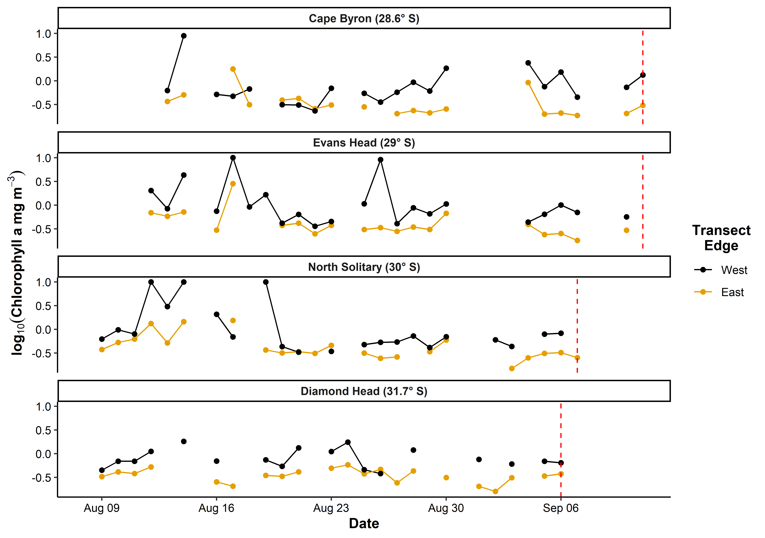

**Figure S2** Satellite observed chlorophyll *a* in the month prior to each transect based upon a 10 x 10 km region around the western and eastern edges of each transect. Gaps are due to days with no data due to cloud cover. The vertical red line shows the day each transect was sampled.

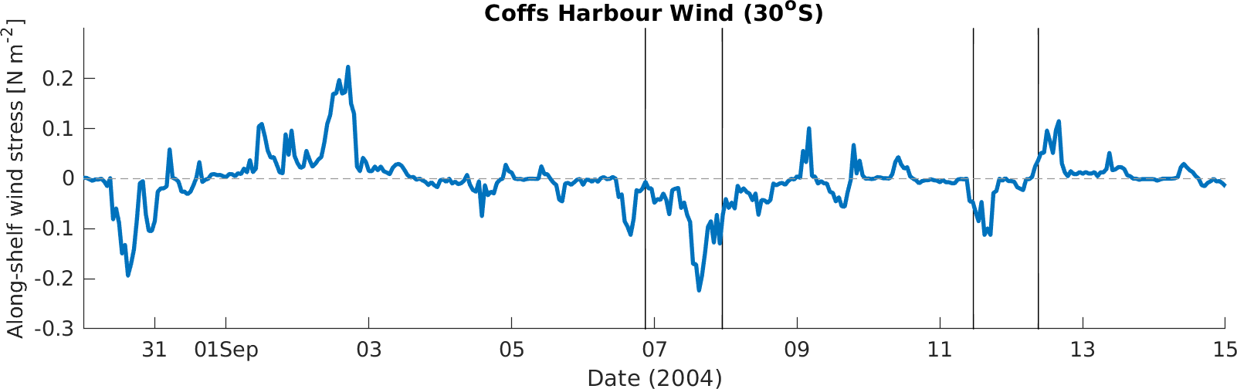

**Figure S3** Time-series of along-shelf (northward) wind stress component calculated from the observed wind at Coffs Harbour (30° S, local time). Negative values show upwelling favourable winds. The vertical black lines show the times of the 4 transects in this study, in chronological order these were Diamond Head, North Solitary, Evans Head then Cape Byron.

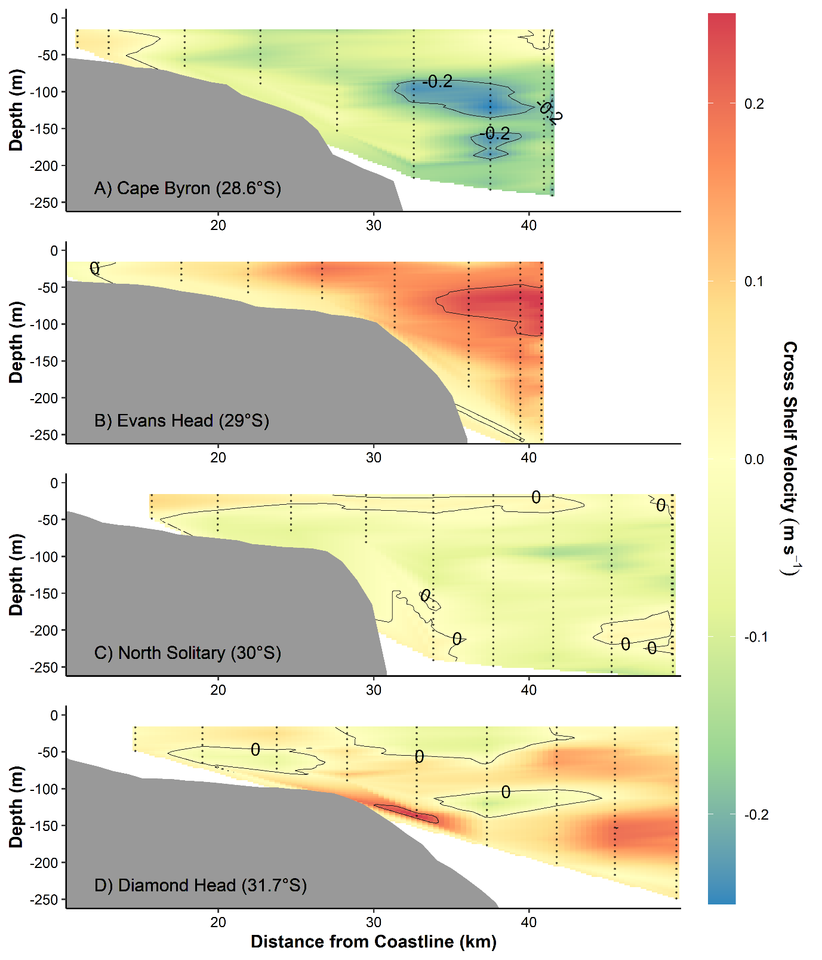

**Figure S4** Cross-shelf velocity across the four cross shelf transects (Figure 1). Transects were conducted with an Acoustic Doppler Current Profiler during a CTD Transect. Grey lines join areas of equal velocity. The red line shows the 21°C isotherm based on the SeaSoar transect. Note there was no 21°C isotherm for Diamond Head.

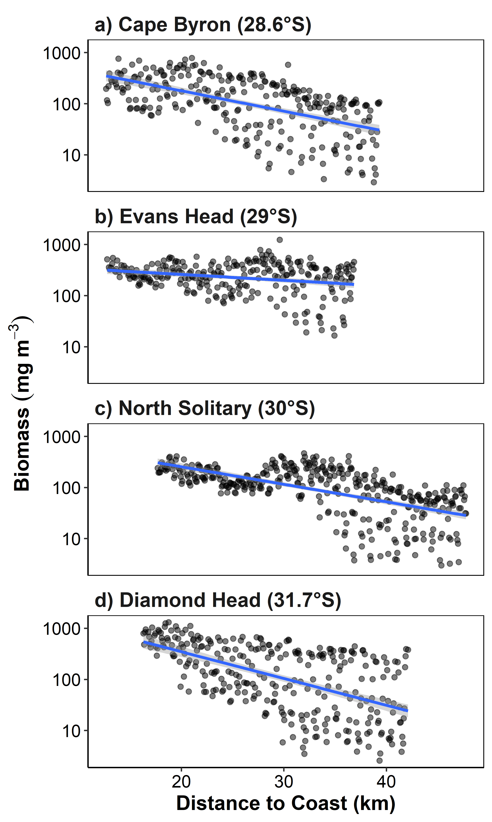

**Figure S5** Biomass by distance from the coast for the four transects. Note the log10 transformed y-axis. Each dot represents a 6 s integration from the OPC mounted on the undulating towed body. Blue lines represent the linear trend line with the 95% confidence intervals shown in grey.

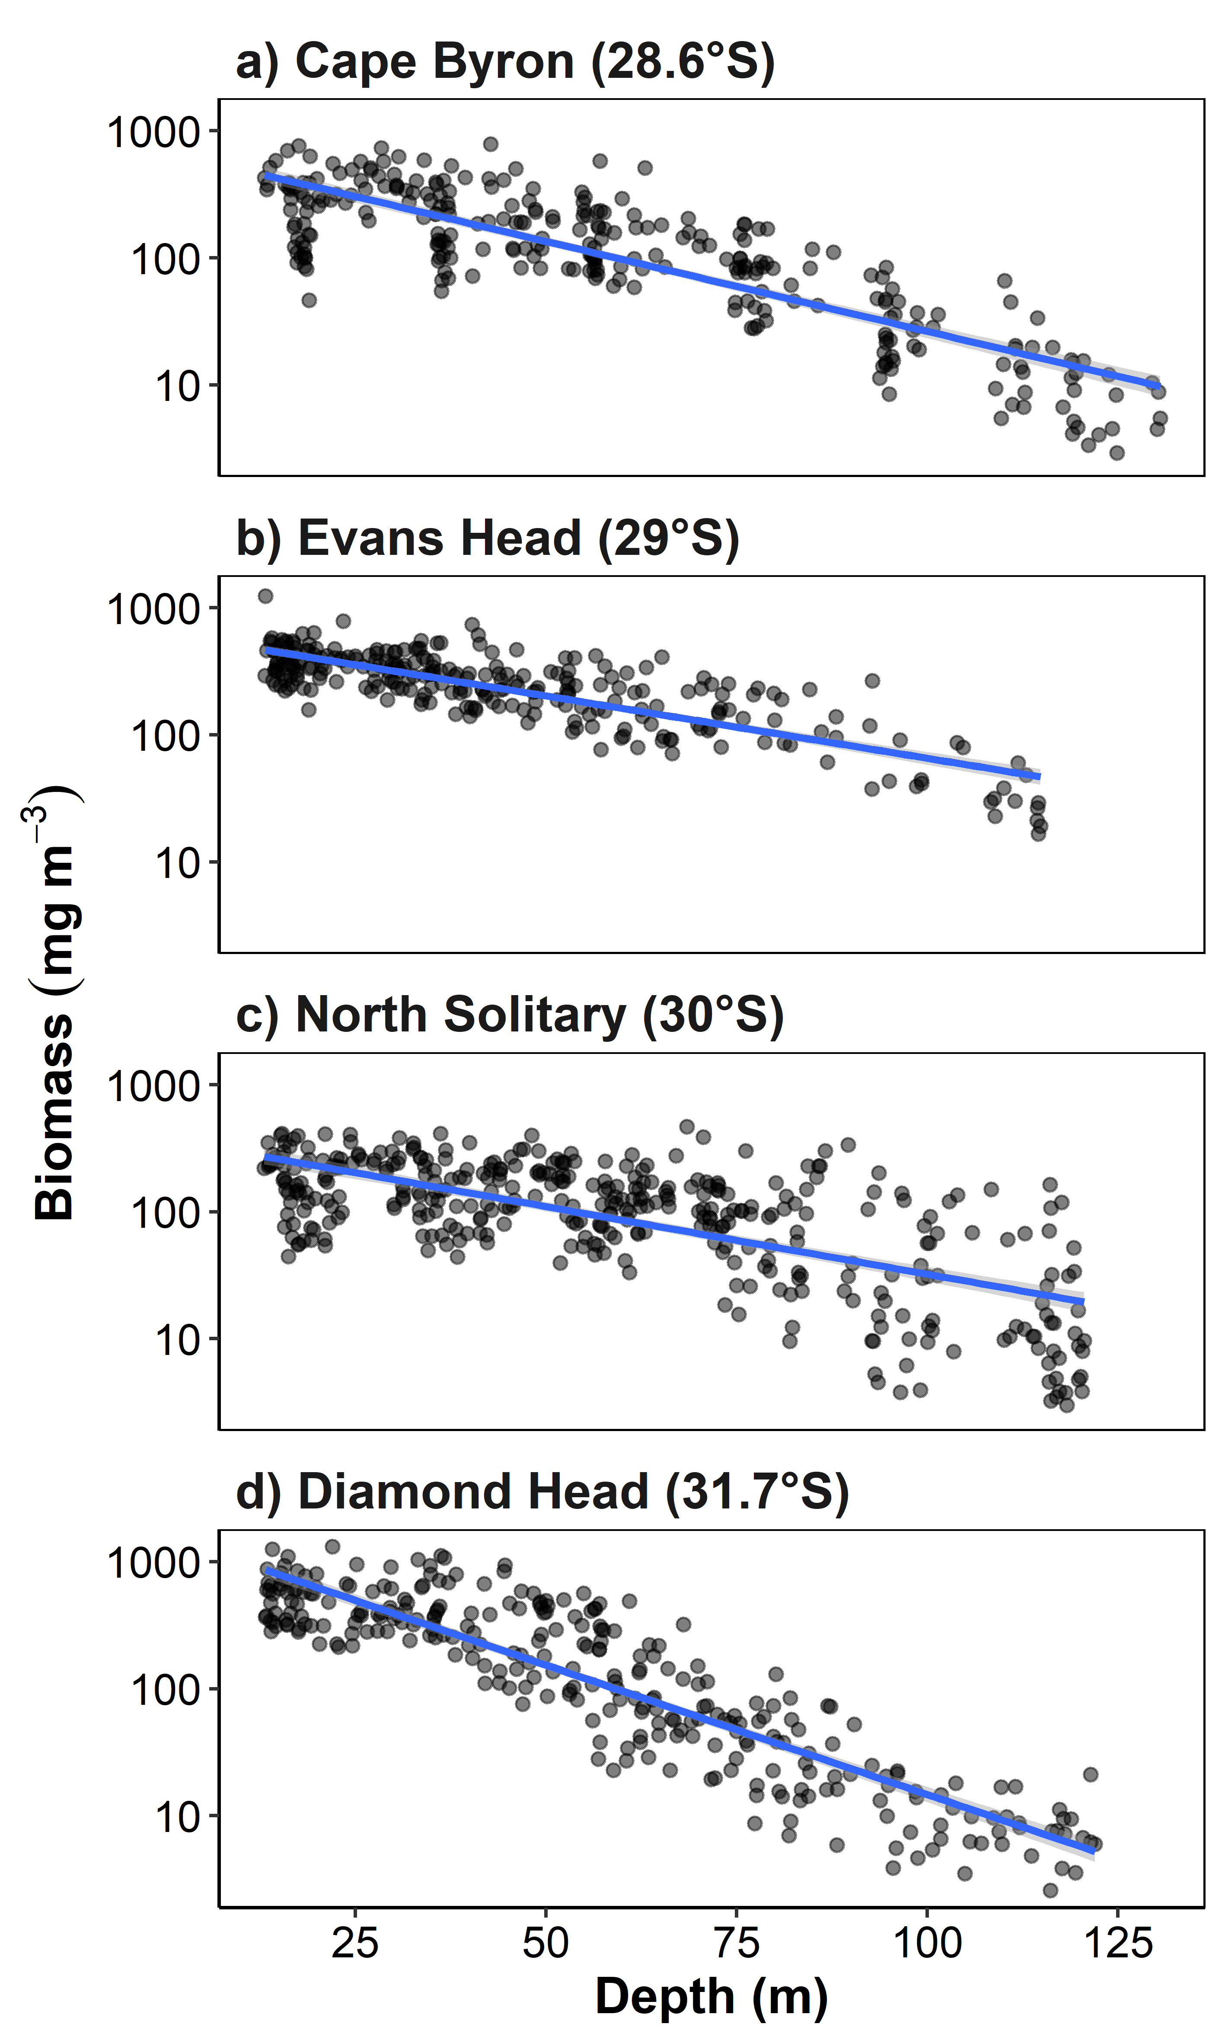

**Figure S6** Biomass by sample depth for the four transects. Note the log1­0 transformed y-axis. Each dot represents a 6 s integration from the OPC mounted on the undulating towed body. Blue lines represent the linear trend line with the 95% confidence intervals shown in grey.

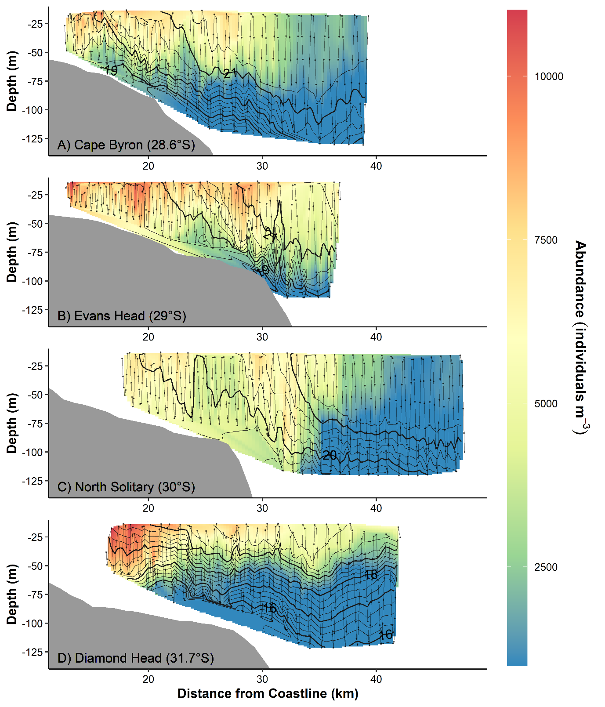

**Figure S7** Cross-shelf interpolations of particulate (zooplankton) abundance (individuals m-3). Measurements were taken as part of a CTD transect (data points shown as dots). Black lines connect areas of equal temperature (°C). Transects were conducted from inshore to offshore with an undulating towed body with the path shown by the grey line with midpoints of each sample shown as dots. Temperature (° C) isotherms are shown in black.

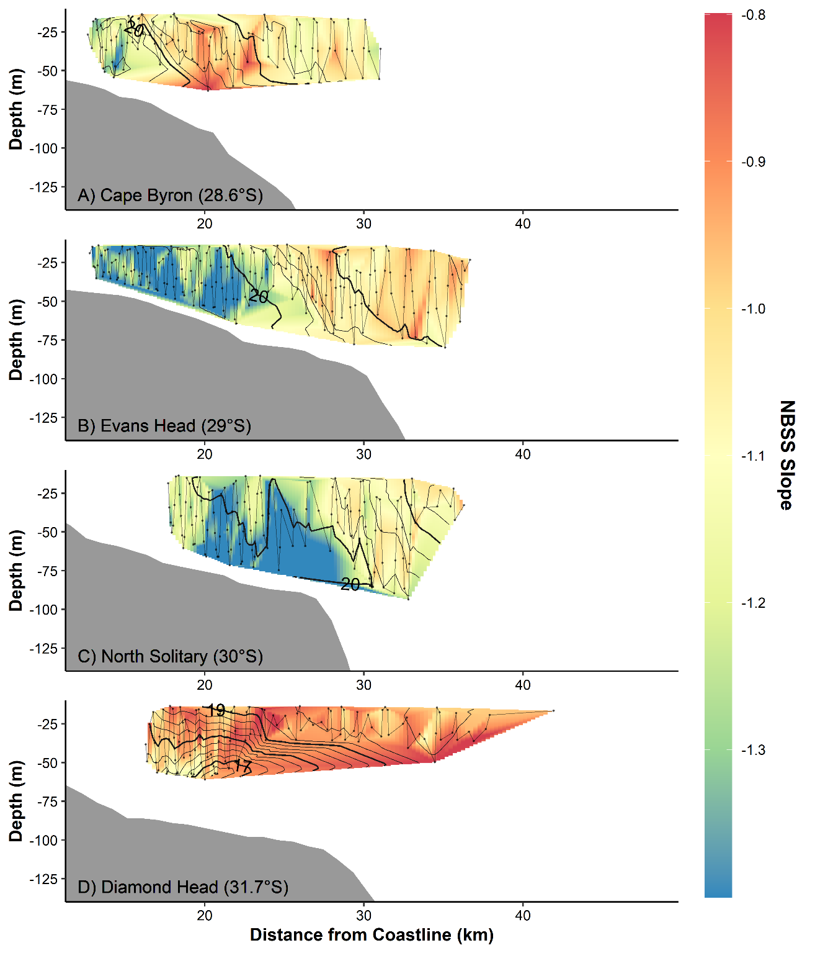

**Figure S8**Interpolations of the particulate (zooplankton) size spectra slope using the Normalised Biomass Size Spectrum (NBSS) method. Transects were conducted from inshore to offshore with an undulating towed body with the path shown by the grey line with midpoints of each sample shown as dots. Temperature (° C) isotherms are shown in black. The NBSS slope estimate was strongly correlated to the pareto *c* chape parameter (*r* = 0.934, *t*535 = 60.362, *p* < 0.001, Figure S7). Note the smaller coverage compared to the pareto *c* shape parameter due to the inability of the NBSS estimate to handle datapoints with few particles.

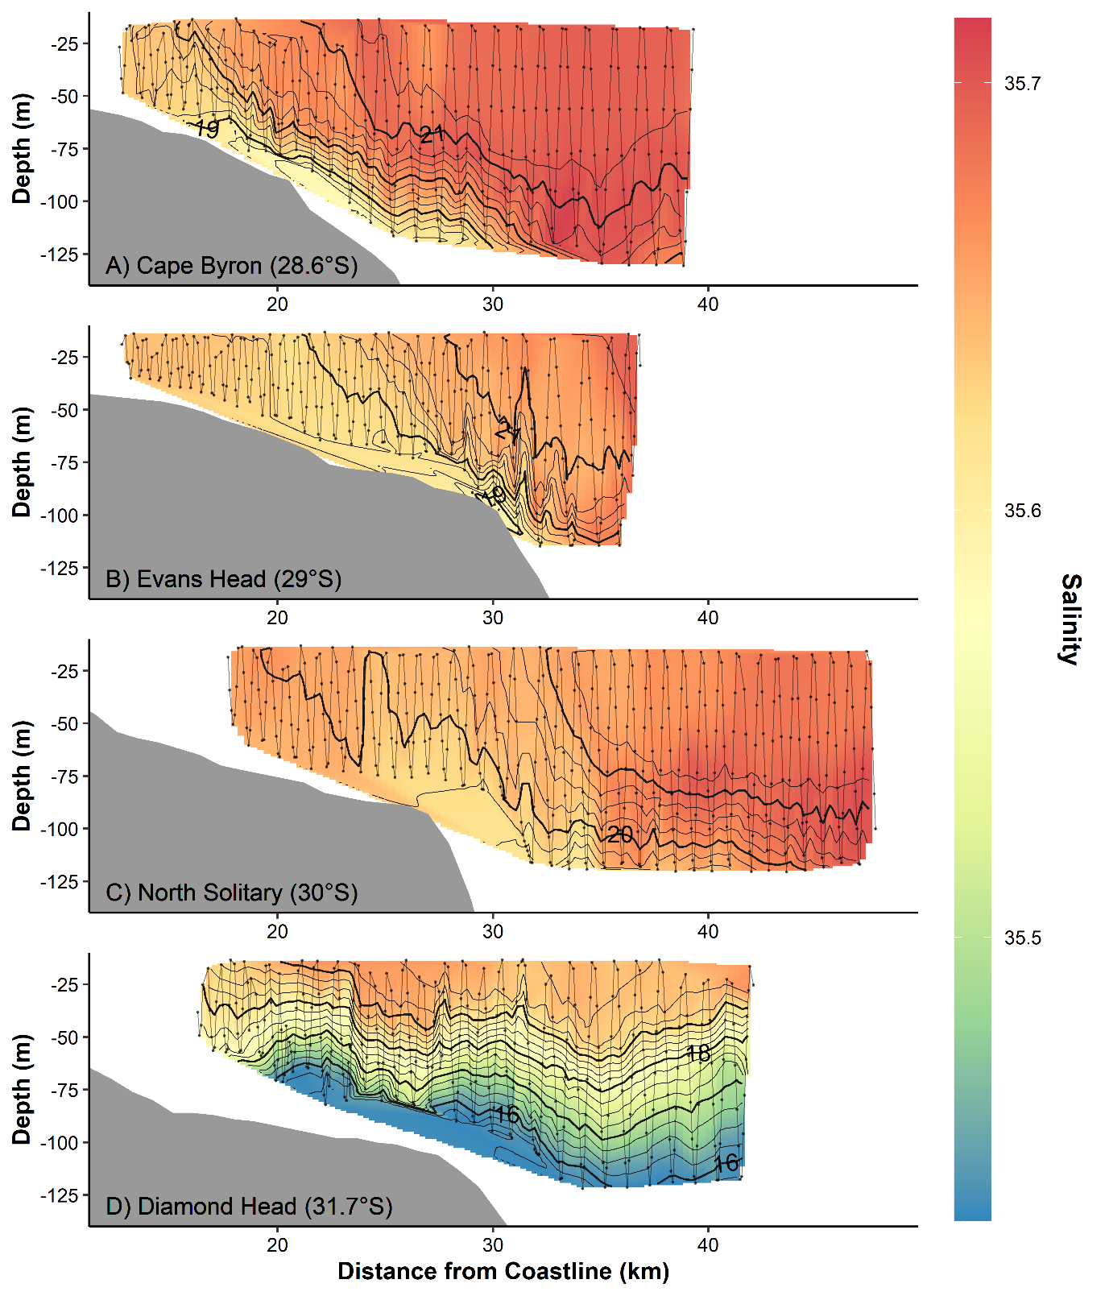

**Figure S9** Cross-shelf interpolations of salinity. Transects were conducted from inshore to offshore with an undulating towed body with the path shown by the grey line with midpoints of each sample shown as dots. Temperature (° C) isotherms are shown in black.

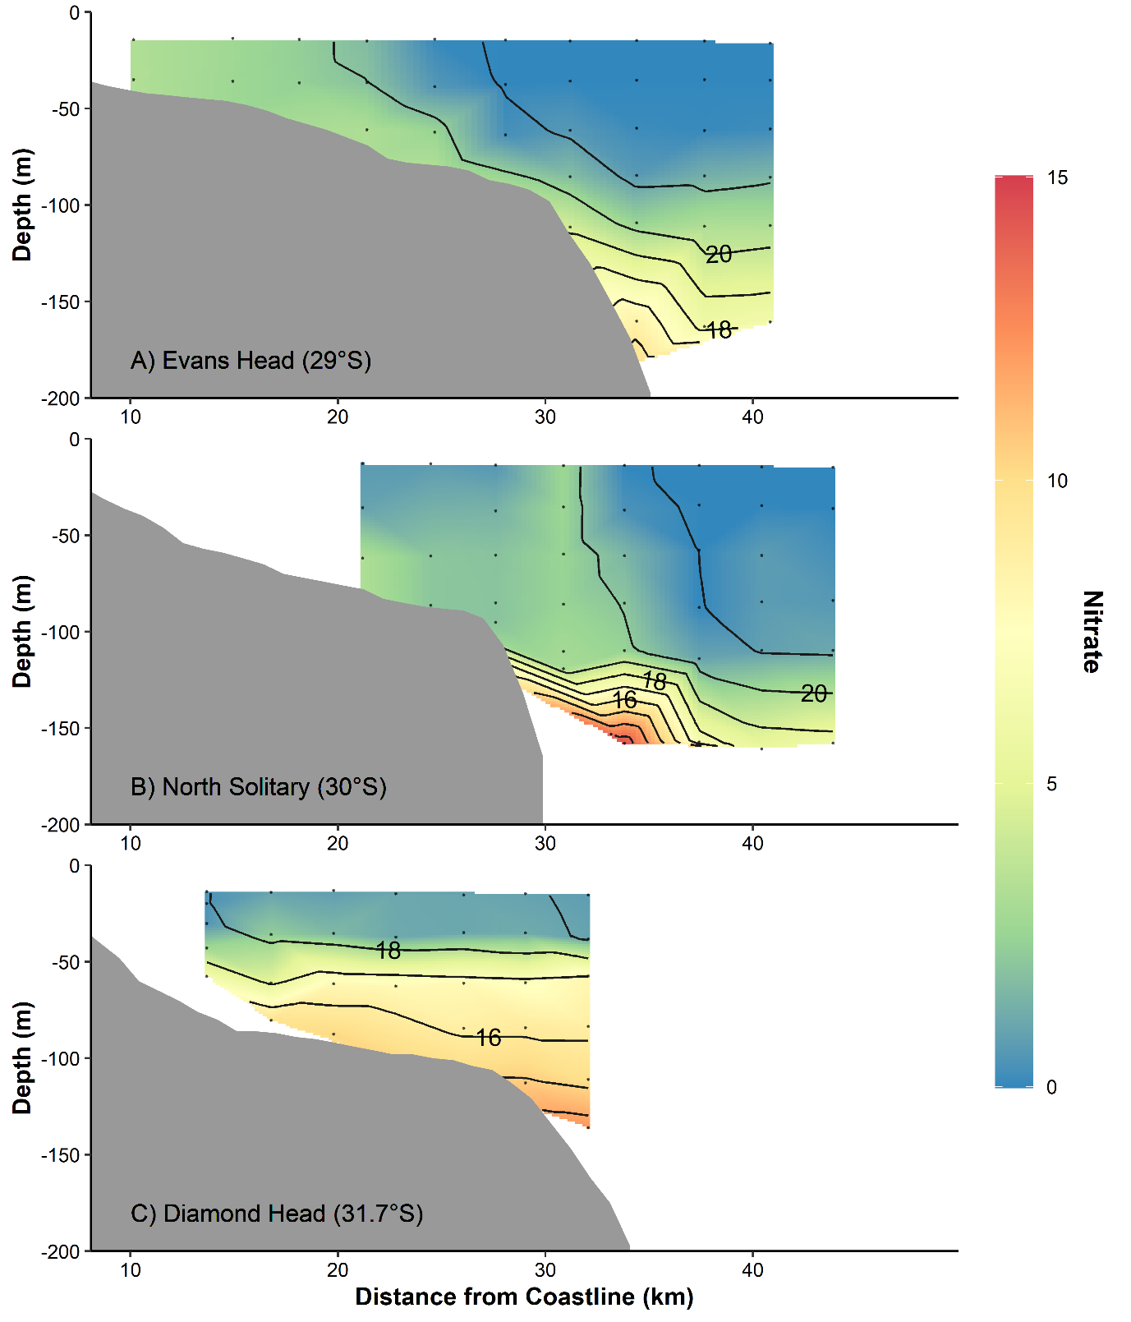

**Figure S10** Cross-shelf interpolations of Nitrate concentration (mmol m-3). Measurements were taken as part of a CTD transect (data points shown as dots). Black lines connect areas of equal temperature (°C).

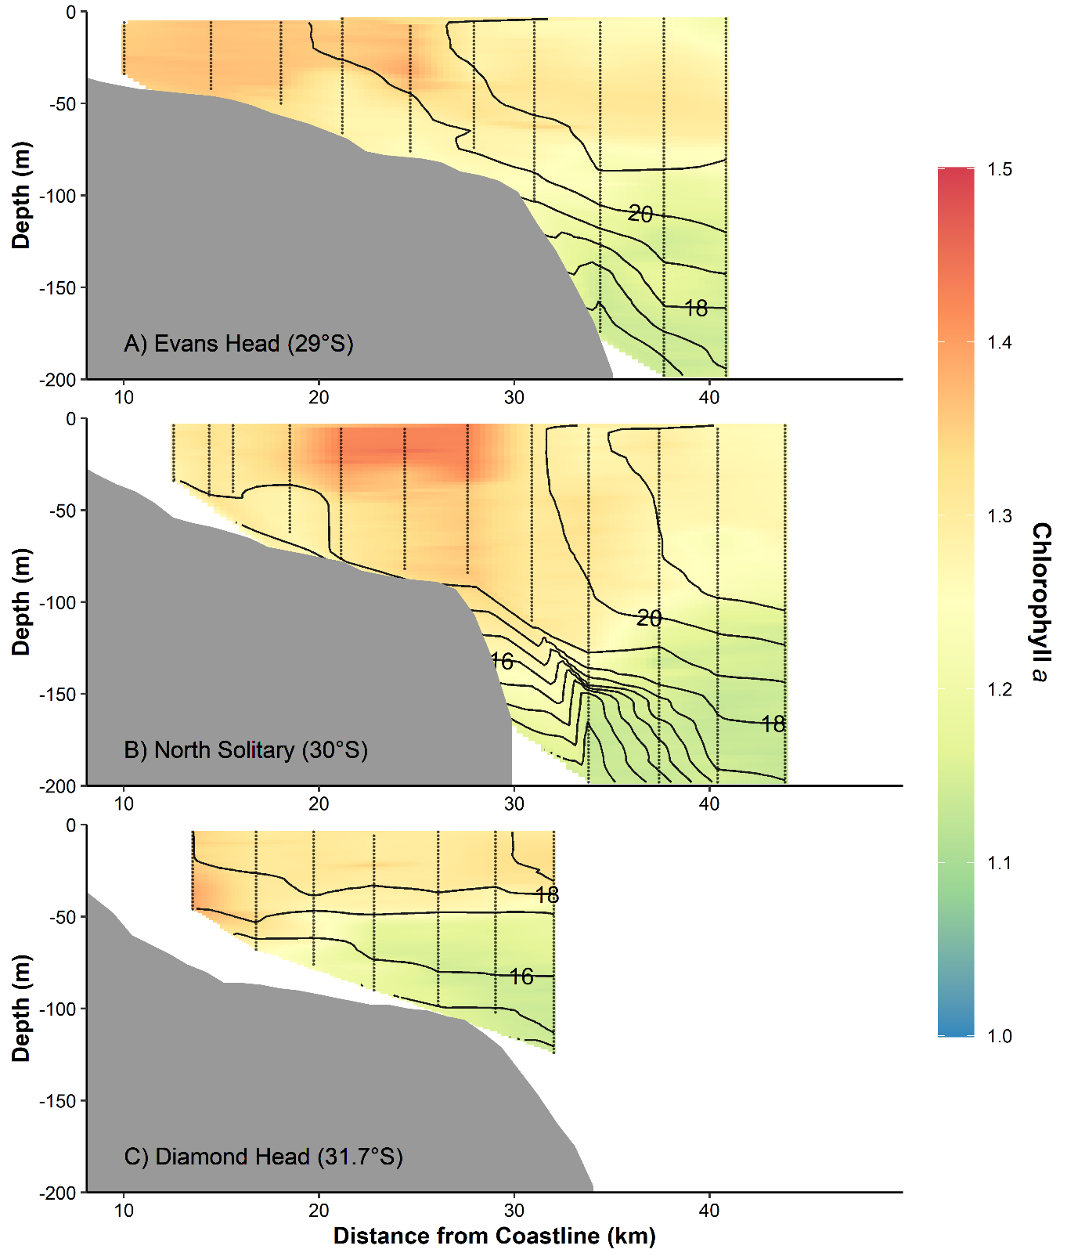

**Figure S11** Cross-shelf interpolations of Chlorophyll *a* concentration (mg m-3). Measurements were taken as part of a CTD transect (data points shown as dots). Black lines connect areas of equal temperature (°C).

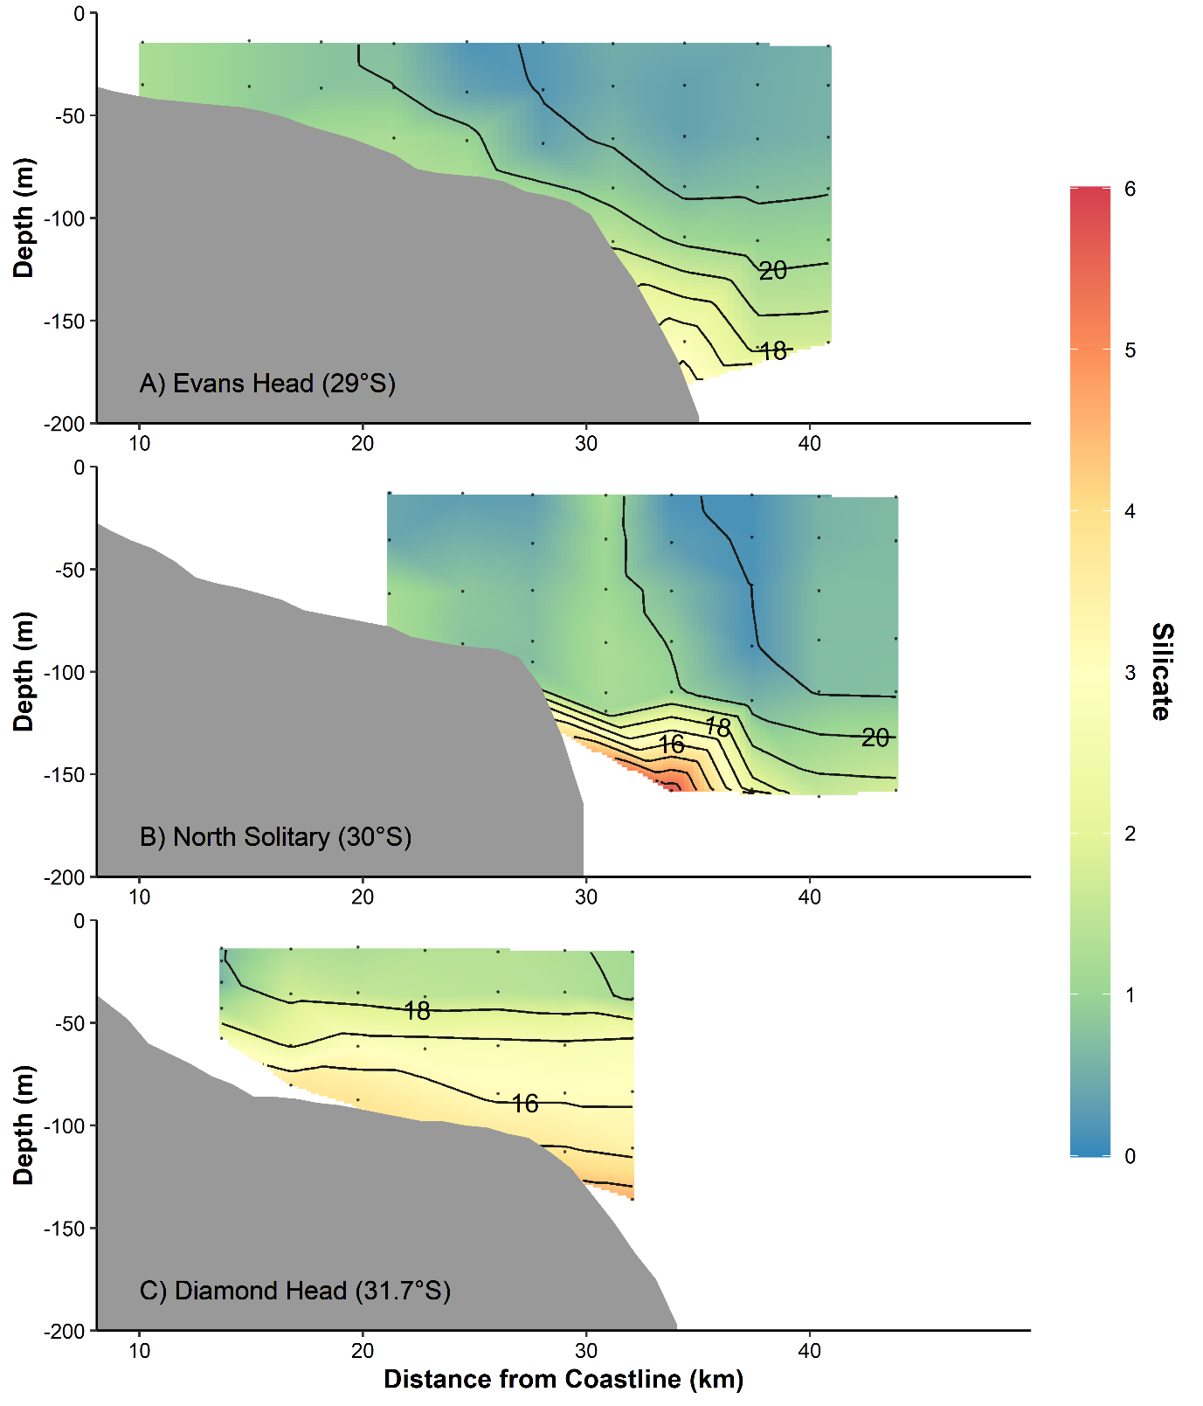

**Figure S12** Cross-shelf interpolations of silicate concentration (mmol m-3). Measurements were taken as part of a CTD transect (data points shown as dots). Black lines connect areas of equal temperature (°C).

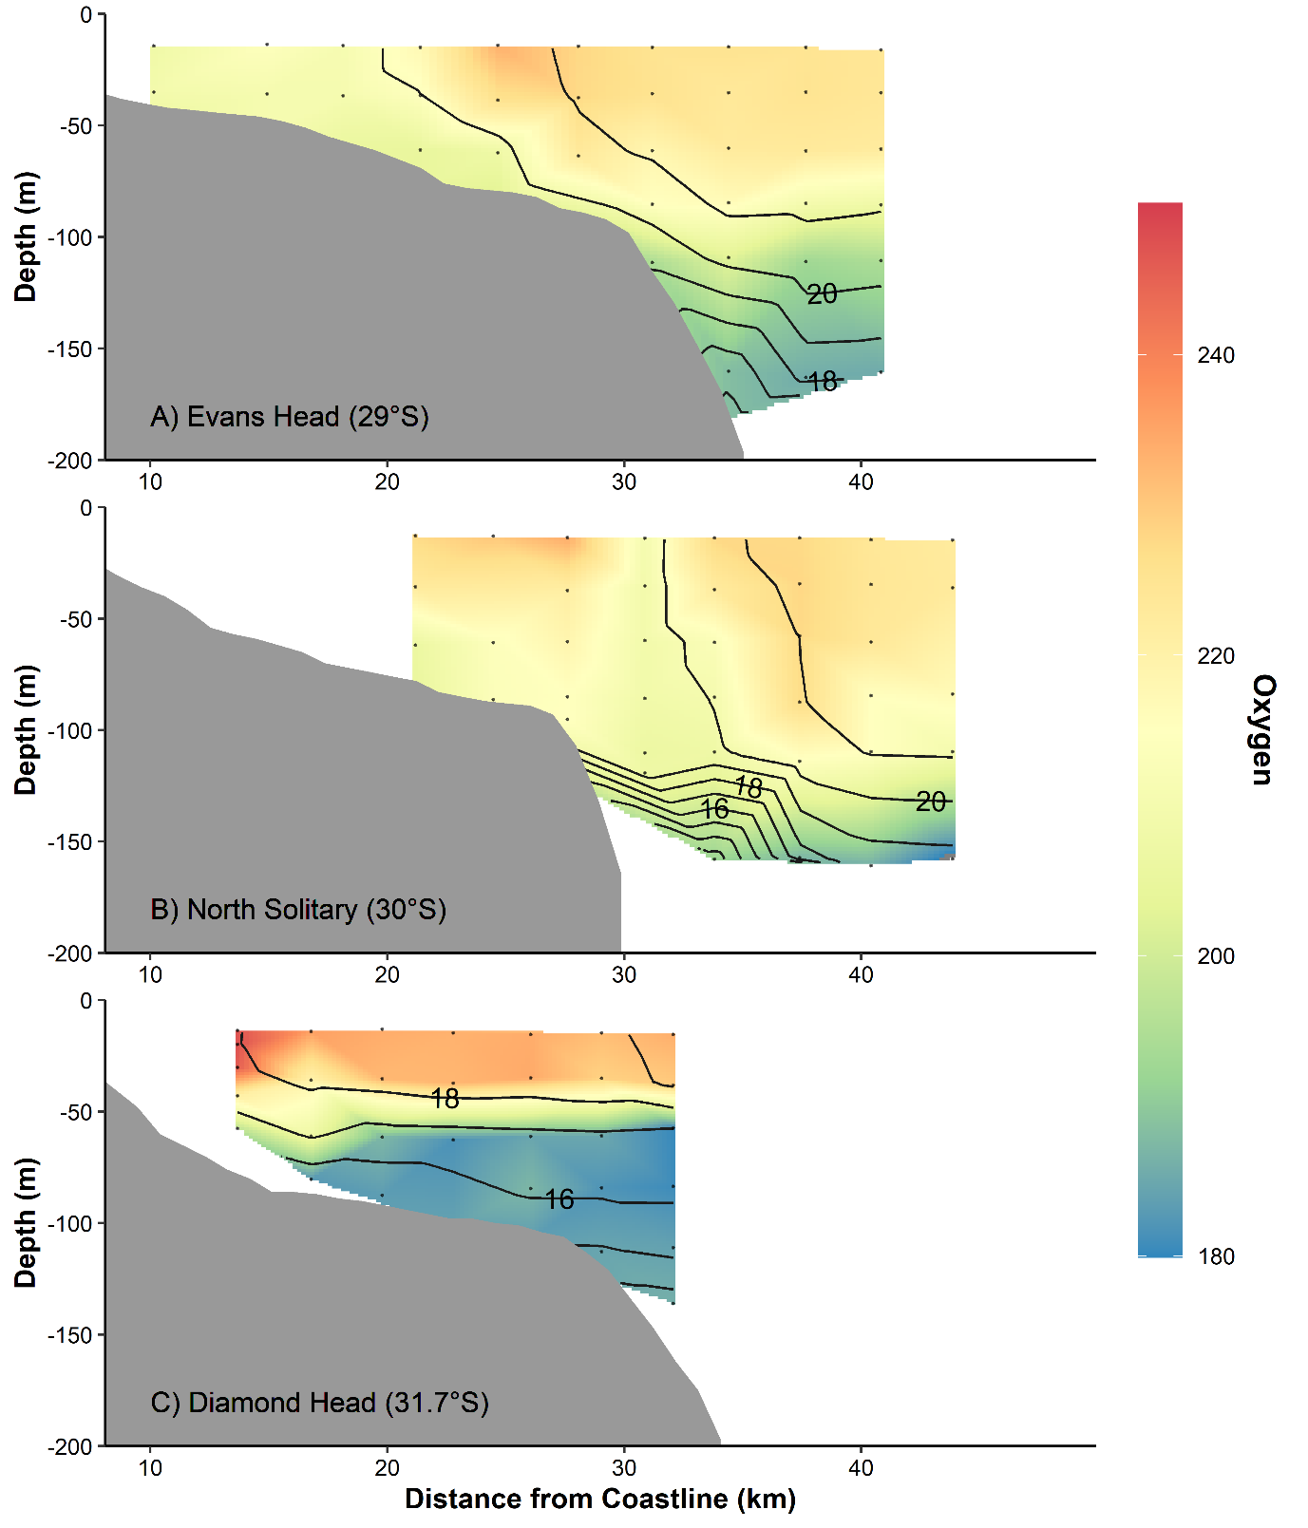

**Figure S13** Cross-shelf interpolations of dissolved oxygen concentration (mmol m-3). Measurements were taken as part of a CTD transect (data points shown as dots). Black lines connect areas of equal temperature (°C).

**Table S1** Details of the additional studies used in the global summary of inshore-offshore zooplankton patterns.Empty cells represent no data.

|  |  |  |  |  |  |  |  |  |  |  |  |  |  |
| --- | --- | --- | --- | --- | --- | --- | --- | --- | --- | --- | --- | --- | --- |
| **Study (Fig 7 ref. #)** | **Region** | **Latitude (°)** | **Longitude (°)** | **Inshore Biomass (mg m-3)** | **Offshore Biomass (mg m-3)** | **Biomass Ratio** | **Inshore Abundance (ind. m-3)** | **Offshore Abundance**  **(ind. m-3)** | **Abundance Ratio** | **Inshore NBSS Slope** | **Offshore NBSS Slope** | **NBSS Slope Ratio** | **Notes** |
| Becker et al (2018) (#1) | Southwest Atlantic Santa Catarina shelf | -28 | -47.5 |  |  |  | 2406 | 580 | 4.15 |  |  |  |  |
| Beckley (2018) (#2) | NW Australia | -15.5 | 122 | 1.34 | 0.33 | 4.06 |  |  |  |  |  |  | biomass converted from ml m-3 |
| Coyle & Pinchuk (2005) (#3) | Gulf of Alaska | 59 | -149 |  |  |  | 267 | 103 | 2.60 |  |  |  |  |
| García-Muñoz et al (2014) (#4) | Drake Passage | -62 | -60 |  |  |  |  |  |  | -0.88 | -0.87 | 1.01 |  |
| Irigoien et al (2009) (#5) | Bay of Biscay - East | 45.5 | -1.5 |  |  |  |  |  |  | -1.25 | -0.75 | 1.67 |  |
| Irigoien et al (2009) (#6) | Bay of Biscay - South | 43.7 | -2.5 |  |  |  |  |  |  | -0.75 | -0.75 | 1 |  |
| Lopes et al (2006) (#7) | Southern Brazilian Shelf | -25 | -46 | 0.35 | 0.12 | 2.92 |  |  |  |  |  |  | highest biomasses from intrusions |
| Marcolin et al (2013) (#8) | SE Atlantic - Abrolhos Bank | -18.5 | -39 | 162.9 | 57.3 | 2.84 |  |  |  | -0.96 | -0.86 | 1.12 |  |
| Nogueira et al (2004) (#9) | Northwest and North Iberian Shelf | 44 | -9 | 82.25 | 57.69 | 1.42 |  |  |  | -0.57 | -1.14 | 0.50 | Biomass is converted from g C m-2 |
| Sabatés et al (1989) (#10) | Western Mediterranean | 42.5 | 2 | 5 | 100 | 0.05 |  |  |  |  |  |  | strongly related to front. |
| Schultes & Lopes (2009) (#11) | SE Atlantic - Abrolhos Bank | -18.5 | -39 |  |  |  |  |  |  | -1.68 | -1.3 | 1.29 |  |
| Skarðhamar et al (2007) (#12) | Northern Norway | 69.5 | 17 |  |  |  | 2000 | 750 | 2.67 |  |  |  | also high at front. |
| Sourisseau & Carlotti (2006) (#13) | Bay of Biscay - East | 45.5 | -1.5 |  |  |  | 17500 | 800 | 21.88 | -1.25 | -0.85 | 1.47 | converted from ind. L-1 |
| Thompson et al (2013) (#14) | Southwest Atlantic | -45 | 58 | 47.9 | 28.8 | 1.66 |  |  |  | -0.58 | -0.41 | 1.42 | non-linear slopes offshore, smaller particles inshore |
| Vandromme et al (2014) (#15) | Bay of Biscay - East | 45.5 | -1.5 |  |  |  |  |  |  | -1.05 | -0.6 | 1.75 |  |
| Vandromme et al (2014) (#16) | Bay of Biscay - South | 43.7 | -2.5 |  |  |  |  |  |  | -0.85 | -0.9 | 0.94 |  |
| Zeldis & Willis (2015) (#17) | New Zealand | -36.6 | 175 |  |  |  | 877 | 377 | 2.33 |  |  |  |  |
| Zhang et al (2019) (#18) | South China Sea | 20 | 116 |  |  |  | 1500 | 500 | 3 |  |  |  |  |
| Schilling et al (This study #19) | Eastern Australia | -30 | 153.5 | 362 | 132 | 2.75 | 7037 | 2340 | 3.01 | -1.18 | -1.09 | 1.08 |  |

**References**

Becker, É. C., Eiras Garcia, C. A., & Freire, A. S. (2018). Mesozooplankton distribution, especially copepods, according to water masses dynamics in the upper layer of the Southwestern Atlantic shelf (26°S to 29°S). *Continental Shelf Research*, *166*, 10–21. https://doi.org/10.1016/j.csr.2018.06.011

Beckley, L. E., Holliday, D., Sutton, A. L., Weller, E., Olivar, M. P., & Thompson, P. A. (2018). Structuring of larval fish assemblages along a coastal-oceanic gradient in the macro-tidal, tropical Eastern Indian Ocean. *Deep Sea Research Part II: Topical Studies in Oceanography*. https://doi.org/10.1016/j.dsr2.2018.03.008

Coyle, K. O., & Pinchuk, A. I. (2005). Seasonal cross-shelf distribution of major zooplankton taxa on the northern Gulf of Alaska shelf relative to water mass properties, species depth preferences and vertical migration behavior. *Deep-Sea Research Part II-Topical Studies in Oceanography*, *52*, 217–245. https://doi.org/10.1016/j.dsr2.2004.09.025

García-Muñoz, C., García, C. M., Lubián, L. M., López-Urrutia, Á., Hernández-León, S., & Ameneiro, J. (2014). Metabolic state along a summer north–south transect near the Antarctic Peninsula: a size spectra approach. *Journal of Plankton Research*, *36*(4), 1074–1091. https://doi.org/10.1093/plankt/fbu042

Irigoien, X., Fernandes, J. A., Grosjean, P., Denis, K., Albaina, A., & Santos, M. (2009). Spring zooplankton distribution in the Bay of Biscay from 1998 to 2006 in relation with anchovy recruitment. *Journal of Plankton Research*, *31*(1), 1–17. https://doi.org/10.1093/plankt/fbn096

Lopes, R. M., Katsuragawa, M., Dias, J. F., Montú, M. A., Muelbert, J. H., Gorri, C., & Brandini, F. P. (2006). Zooplankton and ichthyoplankton distribution on the southern Brazilian shelf: an overview. *Scientia Marina*, *70*(2), 14. https://doi.org/10.3989/scimar.2006.70n2189

Marcolin, C. da R., Schultes, S., Jackson, G. A., & Lopes, R. M. (2013). Plankton and seston size spectra estimated by the LOPC and ZooScan in the Abrolhos Bank ecosystem (SE Atlantic). *Continental Shelf Research*, *70*, 74–87. https://doi.org/10.1016/j.csr.2013.09.022

Nogueira, E., González-Nuevo, G., Bode, A., Varela, M., Morán, X. A. G., & Valdés, L. (2004). Comparison of biomass and size spectra derived from optical plankton counter data and net samples: application to the assessment of mesoplankton distribution along the Northwest and North Iberian Shelf. *ICES Journal of Marine Science*, *61*(4), 508–517. https://doi.org/10.1016/j.icesjms.2004.03.018

Sabatès, A., Gili, J. M., & Pagès, F. (1989). Relationship between zooplankton distribution, geographic characteristics and hydrographic patterns off the Catalan coast (Western Mediterranean). *Marine Biology*, *103*(2), 153–159. https://doi.org/10.1007/BF00543342

Schultes, S., & Lopes, R. M. (2009). Laser Optical Plankton Counter and Zooscan intercomparison in tropical and subtropical marine ecosystems. *Limnology and Oceanography: Methods*, *7*(11), 771–784. https://doi.org/10.4319/lom.2009.7.771

Skarðhamar, J., Slagstad, D., & Edvardsen, A. (2007). Plankton distributions related to hydrography and circulation dynamics on a narrow continental shelf off Northern Norway. *Estuarine, Coastal and Shelf Science*, *75*(3), 381–392. https://doi.org/10.1016/j.ecss.2007.05.044

Sourisseau, M., & Carlotti, F. (2006). Spatial distribution of zooplankton size spectra on the French continental shelf of the Bay of Biscay during spring 2000 and 2001. *Journal of Geophysical Research: Oceans*, *111*(C5). https://doi.org/10.1029/2005jc003063

Thompson, G. A., Dinofrio, E. O., & Alder, V. A. (2013). Structure, abundance and biomass size spectra of copepods and other zooplankton communities in upper waters of the Southwestern Atlantic Ocean during summer. *Journal of Plankton Research*, *35*(3), 610–629. https://doi.org/10.1093/plankt/fbt014

Vandromme, P., Nogueira, E., Huret, M., Lopez-Urrutia, Á., González, G. G.-N., Sourisseau, M., & Petitgas, P. (2014). Springtime zooplankton size structure over the continental shelf of the Bay of Biscay. *Ocean Science*, *10*, 821–835.

Zeldis, J. R., & Willis, K. J. (2015). Biogeographic and trophic drivers of mesozooplankton distribution on the northeast continental shelf and in Hauraki Gulf, New Zealand. *New Zealand Journal of Marine and Freshwater Research*, *49*(1), 69–86. https://doi.org/10.1080/00288330.2014.955806

Zhang, W., Sun, X., Zheng, S., Zhu, M., Liang, J., Du, J., & Yang, C. (2019). Plankton abundance, biovolume, and normalized biovolume size spectra in the northern slope of the South China Sea in autumn 2014 and summer 2015. *Deep Sea Research Part II: Topical Studies in Oceanography*, *167*, 79–92. https://doi.org/10.1016/j.dsr2.2019.07.006